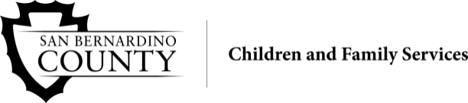
INDEPENDENT LIVING PROGRAM (ILP)
MONTHLY ACTIVITY REPORT
ILP Worker/Emancipation Coach: |  |  |  |  | Date: Click here to enter a date.
Client Name: |  | DOB: Click here to enter a date.
Male | Female |  | Ethnicity:
County of Jurisdiction: |  |  | County of Residence: San Bernardino
1st Quarter (Oct - Dec) | 2nd Quarter (Jan - Mar) |  |  | 3rd Quarter (Apr - Jun) |  | 4th Quarter (Jul - Sept)

Client active to:
Child Welfare Services (CWS) | Probation
Aftercare CWS | Aftercare Probation
Enrolled or eligible for membership in a federally recognized tribe: Yes No Unknown

During reporting period:
Did youth become incarcerated? Yes No Unknown
Highest grade level completed: | Received Special Education services
Completed at least one college/university quarter/semester | Completed any post-secondary non-college training/education

Service/Contact Documentation

SERVICES RECEIVED | Incentive | Date | Date | Date | Date
ILP Career/Job Guidance
ILP Consumer Skills
ILP Credit Results Reviewed
ILP Discuss Credit Counsel/Participate
ILP Education
ILP Education Financial Assistance
ILP Education Post-Secondary
ILP Employment/Vocational Training
ILP Financial Assistance Other
ILP Health Care
ILP Home Management
ILP Housing Options/Locations/THPP+
ILP Interpersonal/Social Skills
ILP Mentoring
ILP Money Management
ILP Needs Assessment
ILP Parenting Skills
ILP Room and Board Financial Assistance
ILP Time Management
ILP Transitional Housing
ILP Transportation

Please email this completed form to: Maria.Mota@hss.sbcounty.gov or Fax to: (909) 388-6717.

