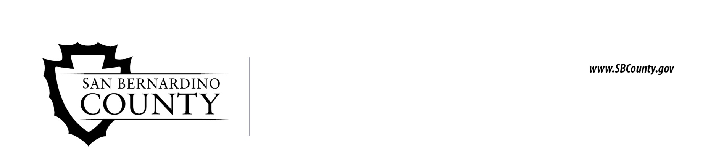

Children and Family Services

Reply to
July 30, 2026  Young Adult Name  Address line one  Address line two | 1900 E. Main Street  Barstow, CA 92311  1495 S. E Street  San Bernardino, CA 92408  1090 E. Broadway Street  Needles, CA 92363  9518 E. 9th Street  Rancho Cucamonga, CA 91730  17621 Foothill Blvd.  Fontana, CA 92335 | 1094 S. E Street  San Bernardino, CA 92415-0084  1504 Gifford Avenue  San Bernardino, CA 92415-0021  15020 Palmdale Rd.  Victorville, CA 92392  56311 Pima Trail  Yucca Valley, CA 92284
TDD - Telephone Services For The Hearing Impaired (909) 252-4703
(04/10) Child and Adult Abuse Hotline 1 (800) 827-8724

Dear Young Adult Name,

An Out-Of-County (OOC) referral and current Transitional Independent Living Plan (TILP) from Name of County was received on or before Date OOC received. We invite you to attend our Independent Living Program (ILP) classes and events in San Bernardino County and we are very pleased to serve you. There may be an incentive, paid by your county, for attending the workshops. Since you are a young adult placed in San Bernardino County you will be offered Extended Foster Care Services.

- Please contact the ILP Social Worker II; Name at Phone to find out what classes are available to young adults in Extended Foster Care.

Communication is important. If you have an e-mail address and would like to be added to our distribution list to receive ILP information, then please notify the ILP Clerk: Name of ILP Clerk at Phone. You may call collect. Flyers of upcoming classes and events will also be sent by mail. If you are on Facebook, please add us to stay better connected and see what exciting things we are doing in the program. You can “Like” us at https://facebook.com/SBCountyILP/.

Sincerely ILP,
Name, SSII/ILP Social Worker II Phone
Name, SSSP/ILP Supervisor Phone
Name, SSP/ILP Coordinator Phone
Name, SSP/ILP Coordinator Phone

